

Course: Compiler Construction Lab

Name: Vaishnawi Kalgaonkar Class: CSE-C3
PRN: 22070122244
Batch: 2022-26

Faculty: Dr. Vipin Tiwari

EXPERIMENT 2

AIM: Count the number of comments, keywords, identifiers, words, lines and spaces from input file.

CODE:

analyser.l

%{
#include <stdio.h> #include <string.h>
int comment_count = 0, keyword_count = 0, identifier_count = 0; int word_count = 0, space_count = 0, line_count = 0;
char *keywords[] = {
"int", "float", "char", "return", "if", "else", "while", "for", "void", "main"
};
int is_keyword(char *word) {
for (int i = 0; i < sizeof(keywords)/sizeof(keywords[0]); i++) { if (strcmp(word, keywords[i]) == 0)
return 1;
}
return 0;
}
%}
%%
"//".* { comment_count++; } "/*"([^*]|\*+[^*/])*\*+"/" { comment_count++; } [a-zA-Z_][a-zA-Z0-9_]* {
word_count++;
if (is_keyword(yytext)) keyword_count++; else identifier_count++;
}
[ \t]+ { space_count += yyleng; }
\n { line_count++; }
. { word_count++; }
%%
int yywrap() { return 1; }

int main() { yylex();
printf("Total Lines : %d\n", line_count); printf("Total Spaces : %d\n", space_count); printf("Total Words : %d\n", word_count); printf("Total Keywords : %d\n", keyword_count); printf("Total Identifiers: %d\n", identifier_count); printf("Total Comments : %d\n", comment_count); return 0;
}

text.txt

// This is a single-line comment
/*
This is a multi-line comment
*/
int main() { int x = 10;
float y = 3.14; char c = 'A'; if (x > 5) {
x = x + 1;
}
}

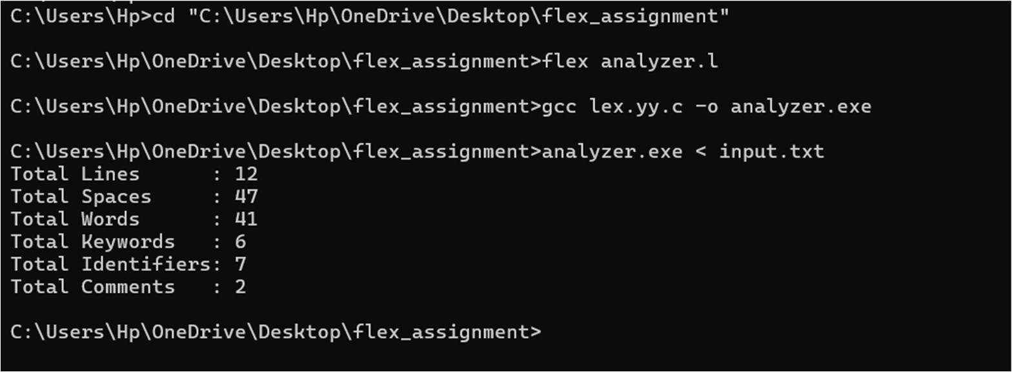
OUTPUT:

POST LAB QUESTIONS

Lex Program to print the total characters, white spaces, tabs in the given input file. counter.l
%{
#include <stdio.h> int char_count = 0; int space_count = 0; int tab_count = 0;
%}
%%
[\t] { tab_count++; char_count++; }
[ ] { space_count++; char_count++; }
.|\n { char_count++; }
%%
int yywrap() { return 1;
}
int main() {
yylex(); // Call the lexer to start processing input printf("Total Characters: %d\n", char_count); printf("Total White Spaces: %d\n", space_count); printf("Total Tabs: %d\n", tab_count);
return 0;
}

input.txt
hii i am vaishnawi kalgaonkar student of sybiosisinstituteof technology

OUTPUT:

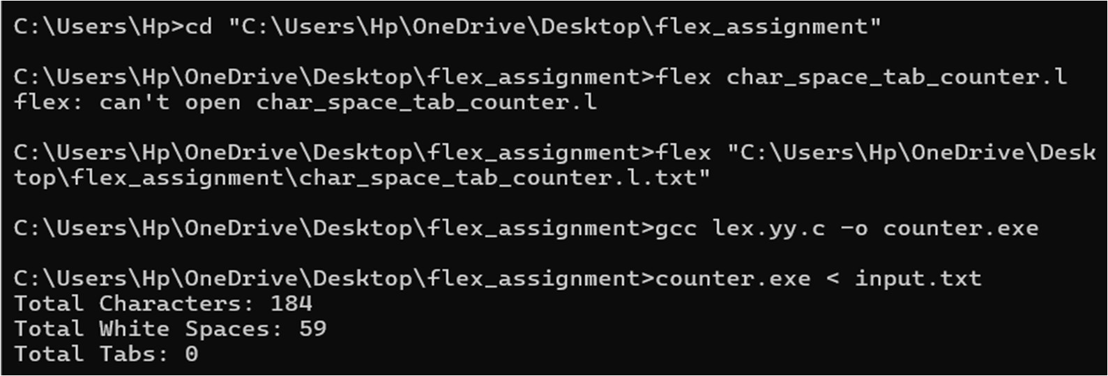

Lex code to count the total number of tokens. token_counter.l
%{
#include <stdio.h> int token_count = 0;
%}
%%
[ \t\n]+ ;
"int"|"float"|"char"|"if"|"else"|"return"|"for"|"while"|"void" { token_count++;
}
[a-zA-Z_][a-zA-Z0-9_]* { token_count++; } [0-9]+ { token_count++; } // Number "+"|"-"|"*"|"/"|"="|"==" { token_count++; }
";"|","|"(" | ")" | "{" | "}" { token_count++; }
. ;
%%

int yywrap() { return 1;
}
int main() { yylex();
printf("Total Tokens: %d\n", token_count); return 0;

}

text1.txt
int a = 5; float b = 10; if (a == b) {
return;
}

OUTPUT:
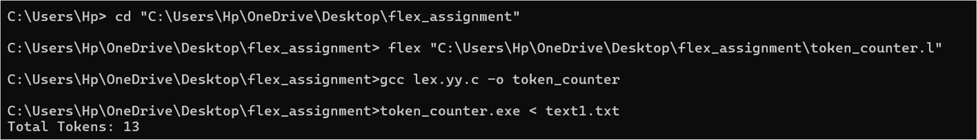

Lex program to count the frequency of the given word in a file. word_frequency.l
%{
#include <stdio.h> #include <string.h> int freq = 0;
char target[] = "hello";
%}

%%
[ \t\n]+ ;
[a-zA-Z]+ {
if (strcmp(yytext, target) == 0) { freq++;
}
}
. ;
%%
int yywrap() {

return 1;
}
int main() { yylex();
printf("Frequency of word '%s': %d\n", target, freq); return 0;
}
hello world.txt hello world hello again
Hello and hello forever. HELLO hello HeLLo

OUTPUT:
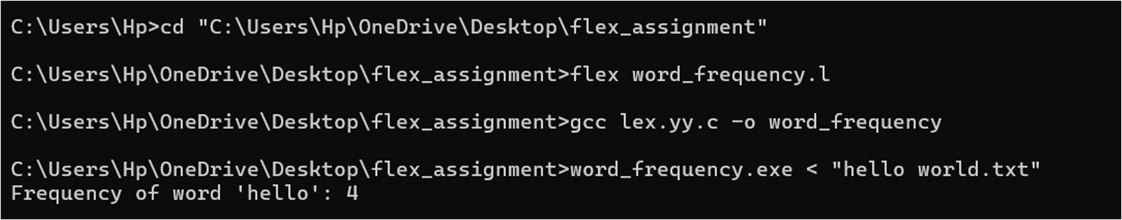

CONCLUSION: This experiment demonstrated how Lex can be used to count comments, keywords, identifiers, words, lines, and spaces in a source file. It provided insight into lexical analysis and the role of pattern matching in compiler design.

